
PIONEER SERVICES

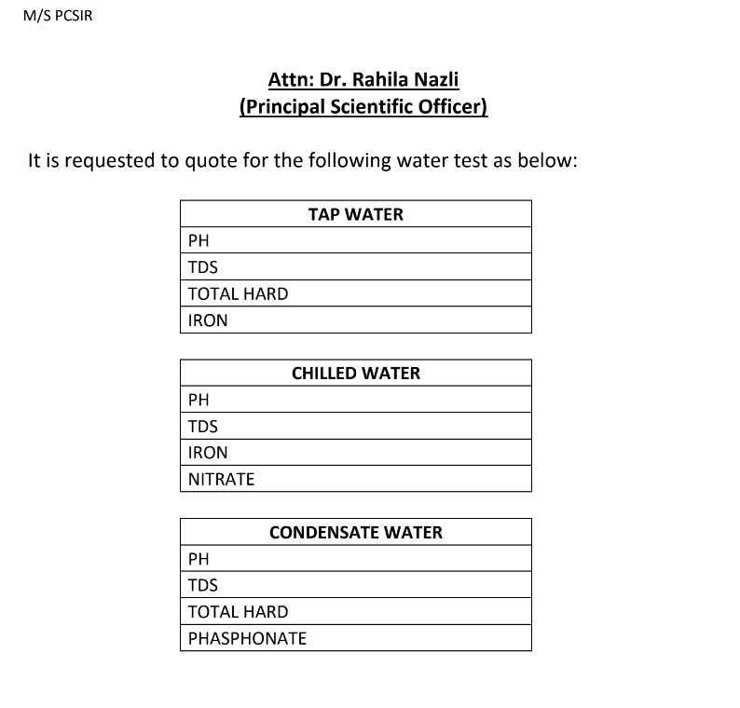

10 Oct 24
M. Bilal Habib


Pioneer Services
2-C 1st Floor Sunset Lane I Phase II
EXT D.H.A Karachi
Tel: (021 35881523 021 35890307)

